Website Design:

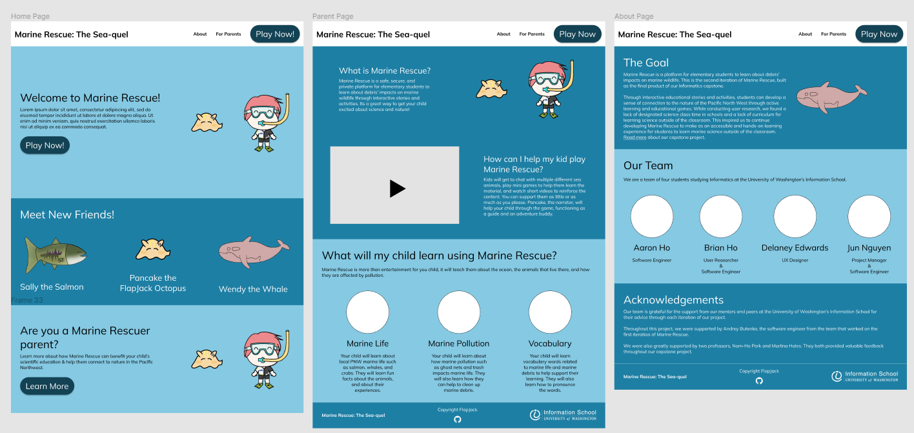

Figma:

<https://www.figma.com/file/GAwPYtxgu7cB9uYnB98nJI/Marine-Rescue%3A-The-Sea-quel?node-id=0%3A1&t=KLdsKytHYv7YVCji-1>